My Feedback System
You Will Get Your Own Username and Password to the Seller Login Page

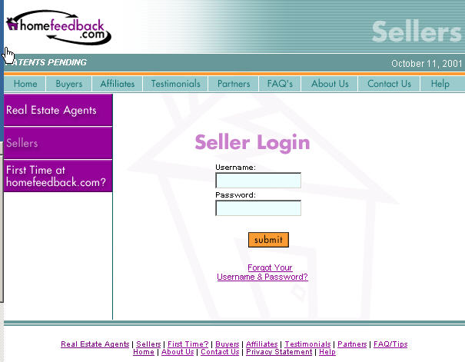

Feedback Form Completed by Showing Agent

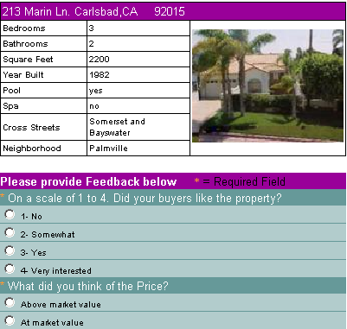
Up to 10 Customizable Questions & Answers

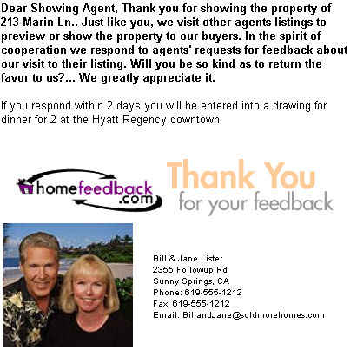

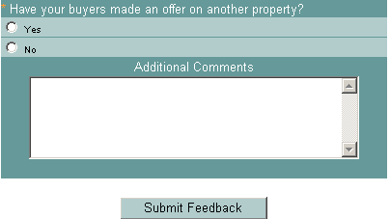

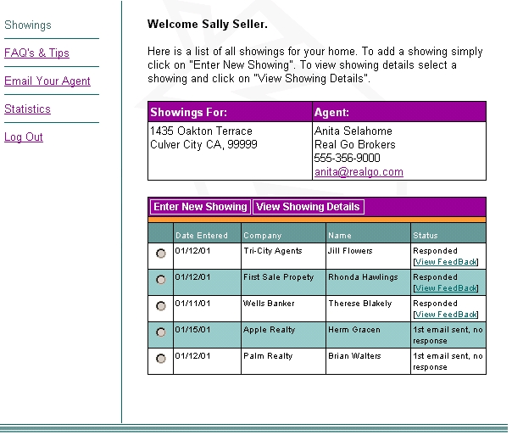

Seller’s Private Control Page
You will be automatically e-mailed feedback the same time I receive it
Seller’s Private Control Page
You will be automatically e-mailed feedback the same time I receive it

Sellers View Statistics

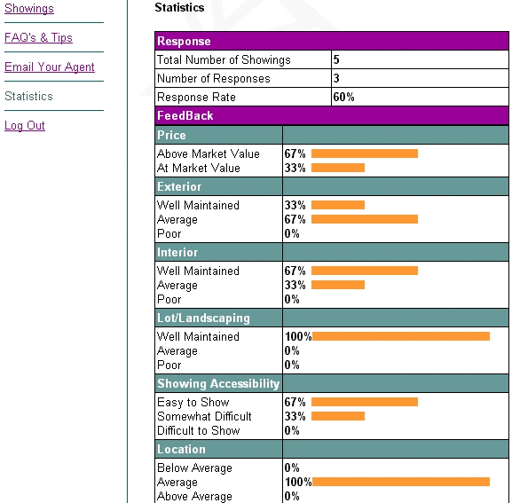


I Quickly E-mail All Showing Agents to Notify Any Change in Your Listing

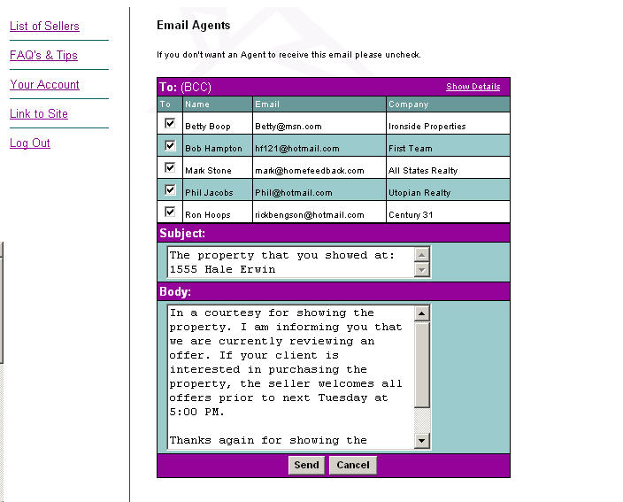

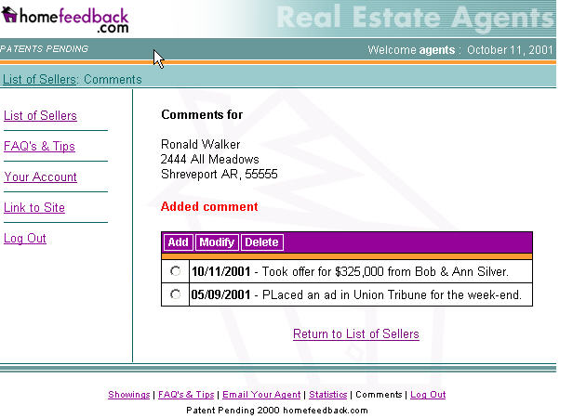
View All of Our Marketing Efforts Anytime

My promise is to put in place a feedback system that keeps you informed and in the loop.
By receiving and reporting feedback promptly, I will be able to sell your home faster and for more money!

